Week 6
3. ReactJS – HOL
• Explain React components
React components are reusable building blocks of a React application. They return HTML using JSX and manage their own structure, behavior, and rendering.

• Identify the differences between components and JavaScript functions
Basis | React Components | JavaScript Functions
Purpose | UI rendering | Logic execution
Returns | JSX (HTML-like syntax) | Data or values
Life Cycle | Has lifecycle methods | No lifecycle
React Integration | Works with React rendering | Does not directly render to UI

• Identify the types of components
- Class Components
- Function Components

• Explain class component
A class component is a React component created using ES6 classes. It has a render() method and can use lifecycle methods and state.
class MyComponent extends React.Component {
render() {
return <h1>Hello from class component</h1>;
}
}

• Explain function component
A function component is a simple JavaScript function that returns JSX. It can use hooks (like useState, useEffect) for state and lifecycle logic.
function MyComponent() {
return <h1>Hello from function component</h1>;
}

• Define component constructor
The constructor is a method in class components used to initialize state and bind event handlers.
constructor(props) {
super(props);
this.state = { count: 0 };
}

• Define render() function
The render() function is used in class components to return JSX that defines what should be displayed on the UI.
render() {
return <div>Welcome</div>;
}

Steps:
Create react app:-
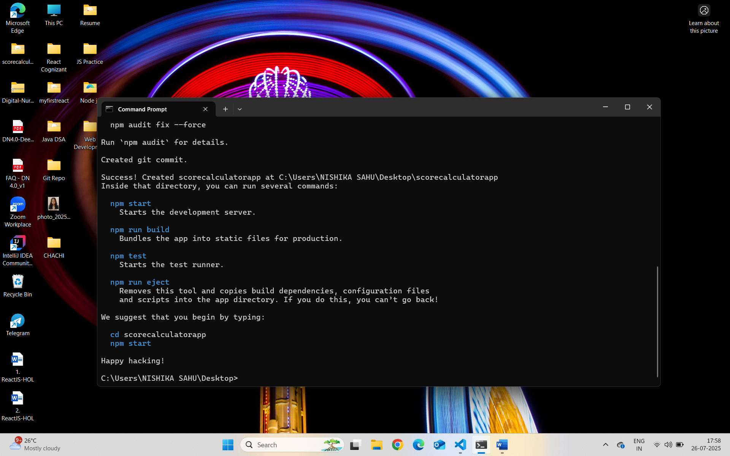
CalculateScore.js :-
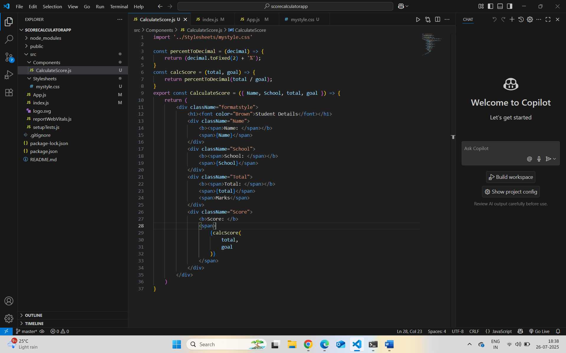

mystyle.css :-
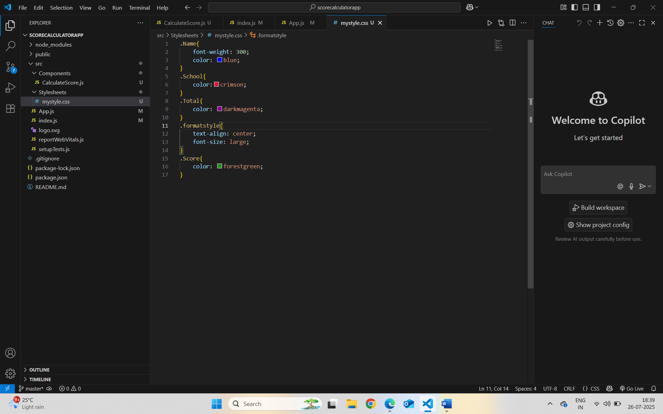
App.js :-
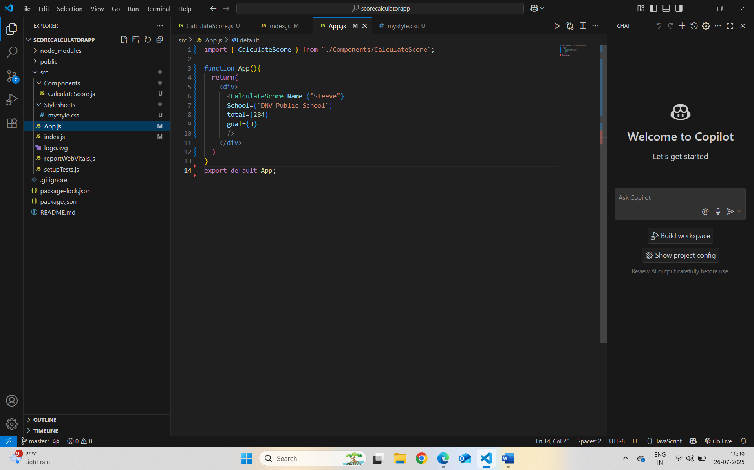
Localhost:3000 :-
